**ObjectAid UML explorer plugin for Eclipse**<http://www.objectaid.com/>

*“The ObjectAid UML Explorer is an agile and lightweight code visualization tool for the Eclipse IDE. It shows your Java source code and libraries in live UML class and sequence diagrams that automatically update as your code changes.”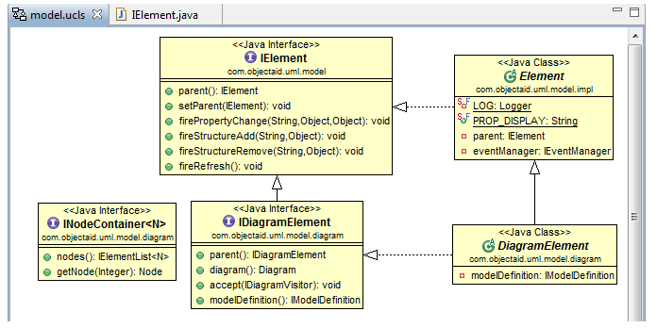 “You simply drag your Java classes onto a diagram from other Eclipse views”***Installation of ObjecAid**  
1. Go to “Help > Install New Software…”  
2. In the 'Available Software' page of the 'Install' wizard, press the 'Add...' button:  
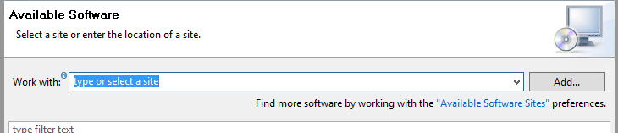  
3. Add the following in the ‘Add Repository’ diaog:  
Name: ObjectAid UML Explorer  
URL: http://www.objectaid.com/update/current  
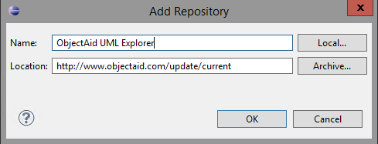  
4. Select the only free plug-in (“ObjectAid Class Diagram”):  
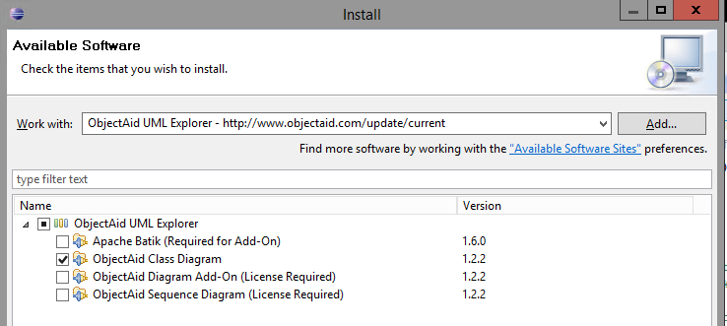  
**Using ObjectAid**1. Create an empty diagram:   
Press Ctrl+N in the package or folder where you want to create the diagram.  
2. Select “ObjectAid UML Diagram”.  
You should see this dialog:  
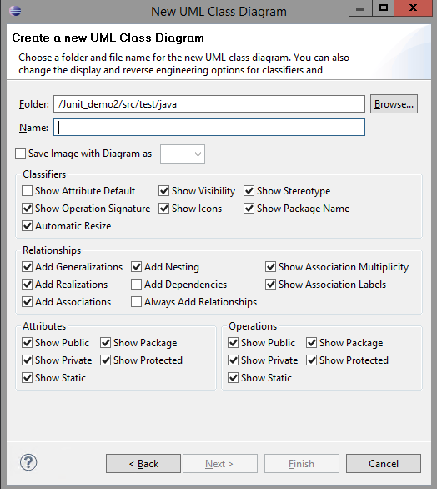  
3. Give the diagram a name, e.g. “model”.   
4. Drag some classes into your diagram:  
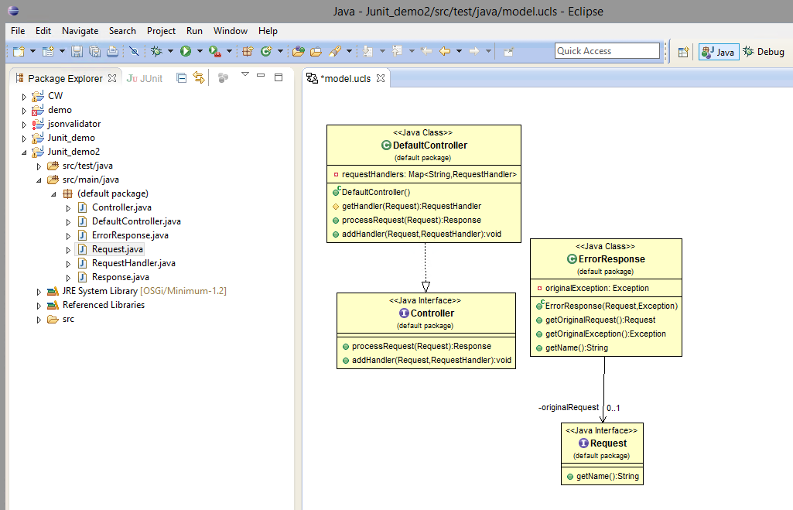  
  
*JeremyC 17-12-2018***END**